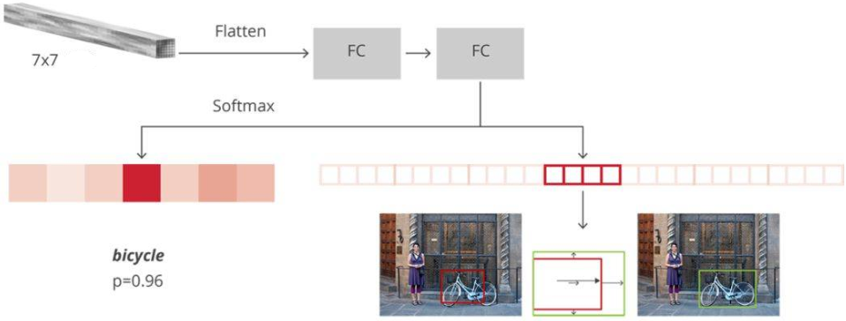

N+1 FC

4N FC

1024

1024

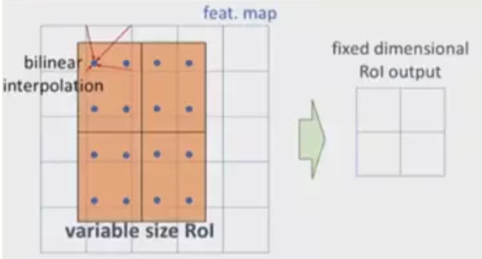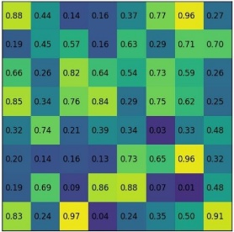

original RoI



quantize RoI

original RoI



Max pooling

The first quantize

The second quantize

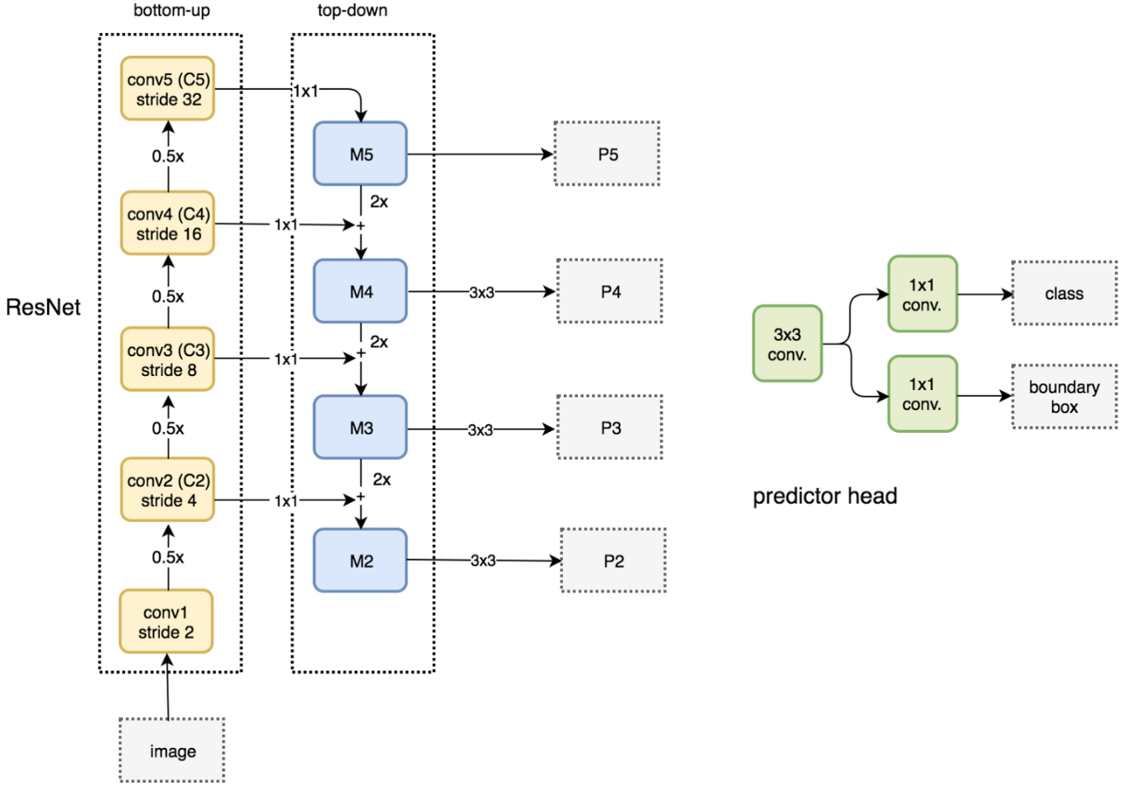

**Lateral connections**